Лабораторная работа №6
Тема: Разработка и интеграция модулей проекта
(командная работа)

Цель: разработать и интегрировать модуль базы данных проекта в Microsoft SQL Server, создать эффективную схему данных, обеспечивающую целостность и удобство хранения информации, а также подготовить основу для дальнейшей реализации бизнес-логики и взаимодействия с приложением с учетом командной работы.
Ход работы
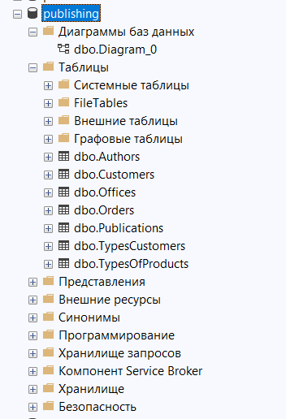
Рисунок 1 — Структура

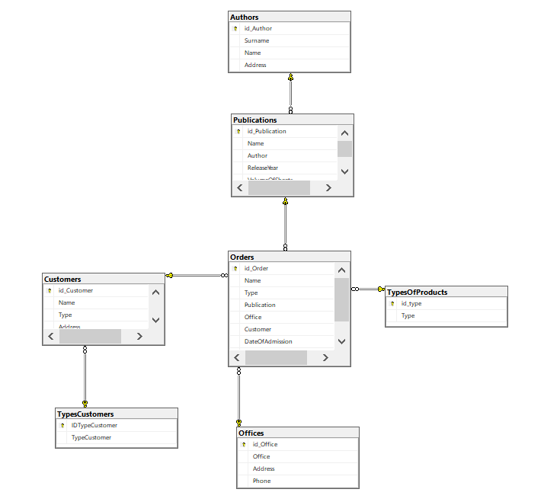
Рисунок 2 — Диаграмма

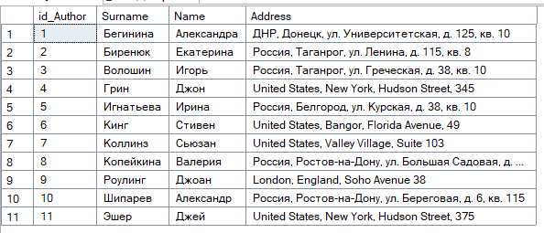
Рисунок 3 — Таблица dbo.Author
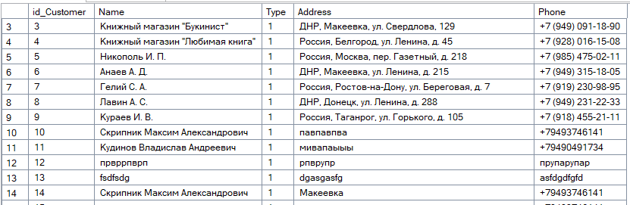
Рисунок 4 — Таблица dbo.Customer

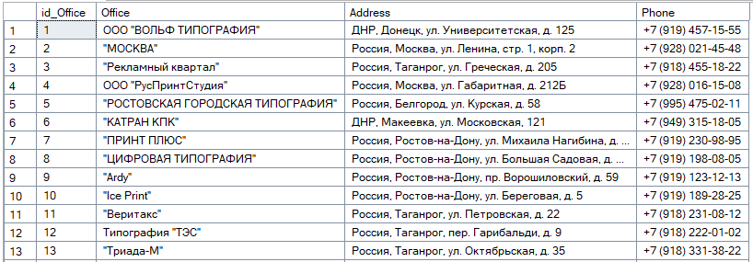
Рисунок 5 — Таблица dbo.Office

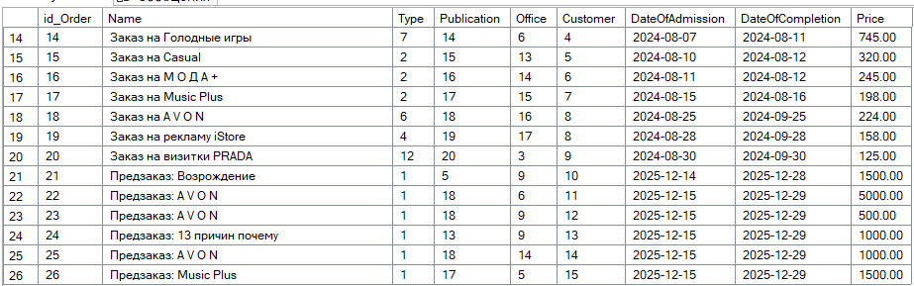
Рисунок 6 — Таблица dbo.Order

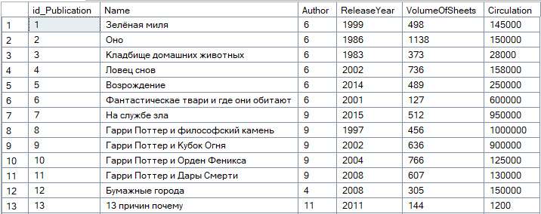
Рисунок 7 — Таблица dbo.Publication

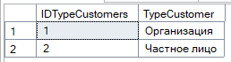
Рисунок 8 — Таблица dbo.TypeCustomers

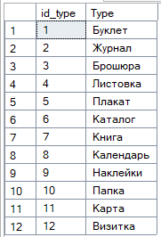
Рисунок 9 — Таблица dbo.TypeOfProducts

Скрипт:
USE [master]
GO

/****** Object: Database [publishing] Script Date: 14.12.2025 18:37:02 ******/
DROP DATABASE [publishing]
GO

/****** Object: Database [publishing] Script Date: 14.12.2025 18:37:02 ******/
CREATE DATABASE [publishing]
CONTAINMENT = NONE
ON PRIMARY
( NAME = N'publishing', FILENAME = N'C:\Program Files\Microsoft SQL Server\MSSQL16.SQLEXPRESS\MSSQL\DATA\publishing.mdf' , SIZE = 8192KB , MAXSIZE = UNLIMITED, FILEGROWTH = 65536KB )
LOG ON
( NAME = N'publishing_log', FILENAME = N'C:\Program Files\Microsoft SQL Server\MSSQL16.SQLEXPRESS\MSSQL\DATA\publishing_log.ldf' , SIZE = 8192KB , MAXSIZE = 2048GB , FILEGROWTH = 65536KB )
WITH CATALOG_COLLATION = DATABASE_DEFAULT, LEDGER = OFF
GO

IF (1 = FULLTEXTSERVICEPROPERTY('IsFullTextInstalled'))
begin
EXEC [publishing].[dbo].[sp_fulltext_database] @action = 'enable'
end
GO

ALTER DATABASE [publishing] SET ANSI_NULL_DEFAULT OFF
GO

ALTER DATABASE [publishing] SET ANSI_NULLS OFF
GO

ALTER DATABASE [publishing] SET ANSI_PADDING OFF
GO

ALTER DATABASE [publishing] SET ANSI_WARNINGS OFF
GO

ALTER DATABASE [publishing] SET ARITHABORT OFF
GO

ALTER DATABASE [publishing] SET AUTO_CLOSE ON
GO

ALTER DATABASE [publishing] SET AUTO_SHRINK OFF
GO

ALTER DATABASE [publishing] SET AUTO_UPDATE_STATISTICS ON
GO

ALTER DATABASE [publishing] SET CURSOR_CLOSE_ON_COMMIT OFF
GO

ALTER DATABASE [publishing] SET CURSOR_DEFAULT GLOBAL
GO

ALTER DATABASE [publishing] SET CONCAT_NULL_YIELDS_NULL OFF
GO

ALTER DATABASE [publishing] SET NUMERIC_ROUNDABORT OFF
GO

ALTER DATABASE [publishing] SET QUOTED_IDENTIFIER OFF
GO

ALTER DATABASE [publishing] SET RECURSIVE_TRIGGERS OFF
GO

ALTER DATABASE [publishing] SET ENABLE_BROKER
GO

ALTER DATABASE [publishing] SET AUTO_UPDATE_STATISTICS_ASYNC OFF
GO

ALTER DATABASE [publishing] SET DATE_CORRELATION_OPTIMIZATION OFF
GO

ALTER DATABASE [publishing] SET TRUSTWORTHY OFF
GO

ALTER DATABASE [publishing] SET ALLOW_SNAPSHOT_ISOLATION OFF
GO

ALTER DATABASE [publishing] SET PARAMETERIZATION SIMPLE
GO

ALTER DATABASE [publishing] SET READ_COMMITTED_SNAPSHOT OFF
GO

ALTER DATABASE [publishing] SET HONOR_BROKER_PRIORITY OFF
GO

ALTER DATABASE [publishing] SET RECOVERY SIMPLE
GO

ALTER DATABASE [publishing] SET MULTI_USER
GO

ALTER DATABASE [publishing] SET PAGE_VERIFY CHECKSUM
GO

ALTER DATABASE [publishing] SET DB_CHAINING OFF
GO

ALTER DATABASE [publishing] SET FILESTREAM( NON_TRANSACTED_ACCESS = OFF )
GO

ALTER DATABASE [publishing] SET TARGET_RECOVERY_TIME = 60 SECONDS
GO

ALTER DATABASE [publishing] SET DELAYED_DURABILITY = DISABLED
GO

ALTER DATABASE [publishing] SET ACCELERATED_DATABASE_RECOVERY = OFF
GO

ALTER DATABASE [publishing] SET QUERY_STORE = ON
GO

ALTER DATABASE [publishing] SET QUERY_STORE (OPERATION_MODE = READ_WRITE, CLEANUP_POLICY = (STALE_QUERY_THRESHOLD_DAYS = 30), DATA_FLUSH_INTERVAL_SECONDS = 900, INTERVAL_LENGTH_MINUTES = 60, MAX_STORAGE_SIZE_MB = 1000, QUERY_CAPTURE_MODE = AUTO, SIZE_BASED_CLEANUP_MODE = AUTO, MAX_PLANS_PER_QUERY = 200, WAIT_STATS_CAPTURE_MODE = ON)
GO

ALTER DATABASE [publishing] SET READ_WRITE
GO

